ASSIGNMENT 5

EMPLOYEES (Employee_Id, First_Name, Last_Name, Email, Phone_Number, Hire_Date, Job_Id, Salary, Commission_Act, Manager_Id, Department_Id)

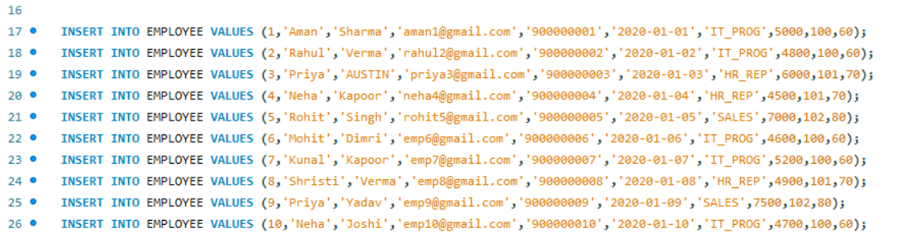
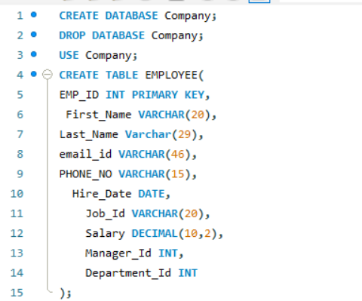

( a) Find out the employee id, names, salaries of all the employees
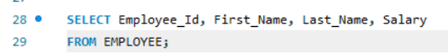
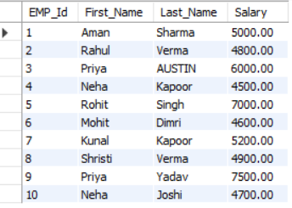

( b) List out the employees who works under manager 100
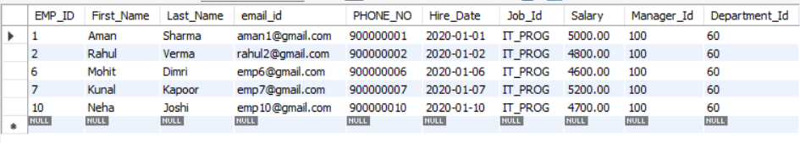
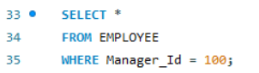

( c) Find the names of the employees who have a salary greater than or equal to 4800
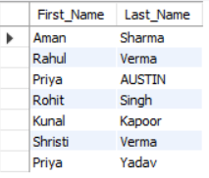
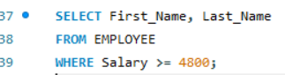

( d) List out the employees whose last name is ‘Verma’
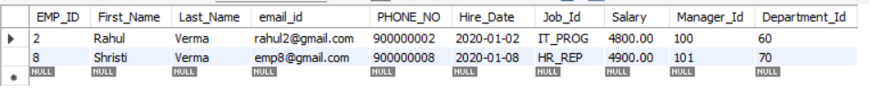
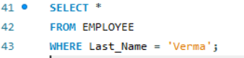

( e) Find the names of the employees who works in departments 60,70 and 80
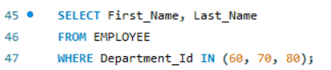
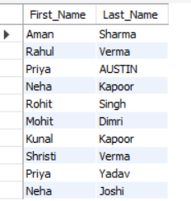

( f ) Display the unique Manager_Id.

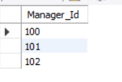

Assignment 6

Create Client_master with the following fields (ClientNO, Name, Address, City, State, bal_due)
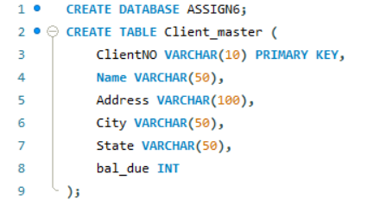
( a ) Insert five records
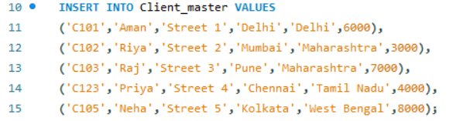
( b ) Find the names of clients whose bal_due> 5000 .
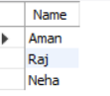
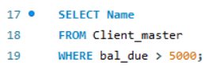

( c ) Change the bal_due of ClientNO “ C123” to Rs. 5100
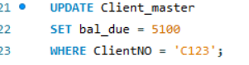

( d ) Change the name of Client_master to Client12.


( e ) Display the bal_due heading as “BALANCE”
